Student Enrollment & Course Management System (SECMS)

Activting:1
Creating a developer org in salesforce.
Go to https://developer.salesforce.com/signup
On the sign up form, enter the program
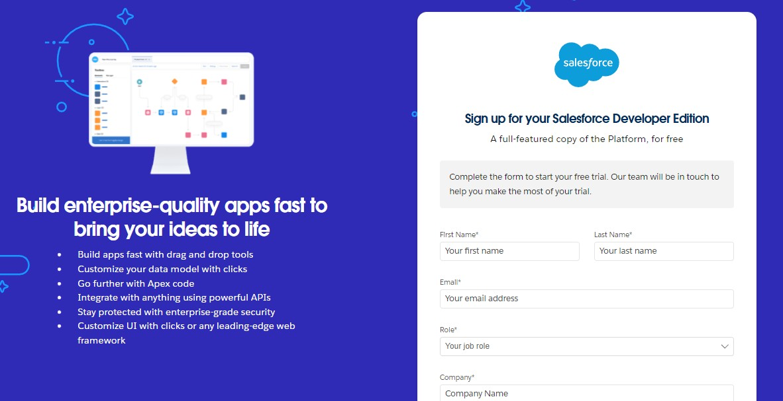
First name & Last name
Email
Role : Developer
Company : College Name
County : India
Postal Code : pin code
Username : should be a combination of your name and company This need not be an actual email id, you can give anything in the format : username@organization.com
Click on sign me up after filling these.

Activity 2: Account Activation:

- Go to the inbox of the email that you used while signing up. Click on the verify account to activate your account. The email may take 5-10mins.

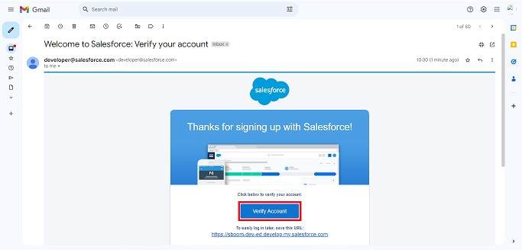

- Click on Verify Account
- Give a password and answer a security question and click on change password.
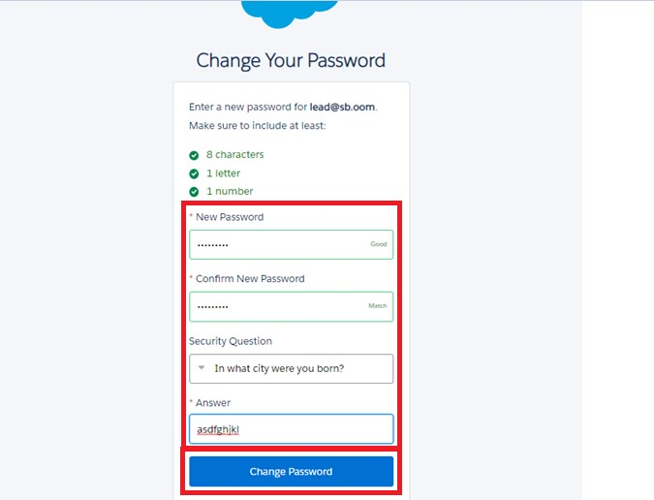

- Then you will redirect to your salesforce setup page.
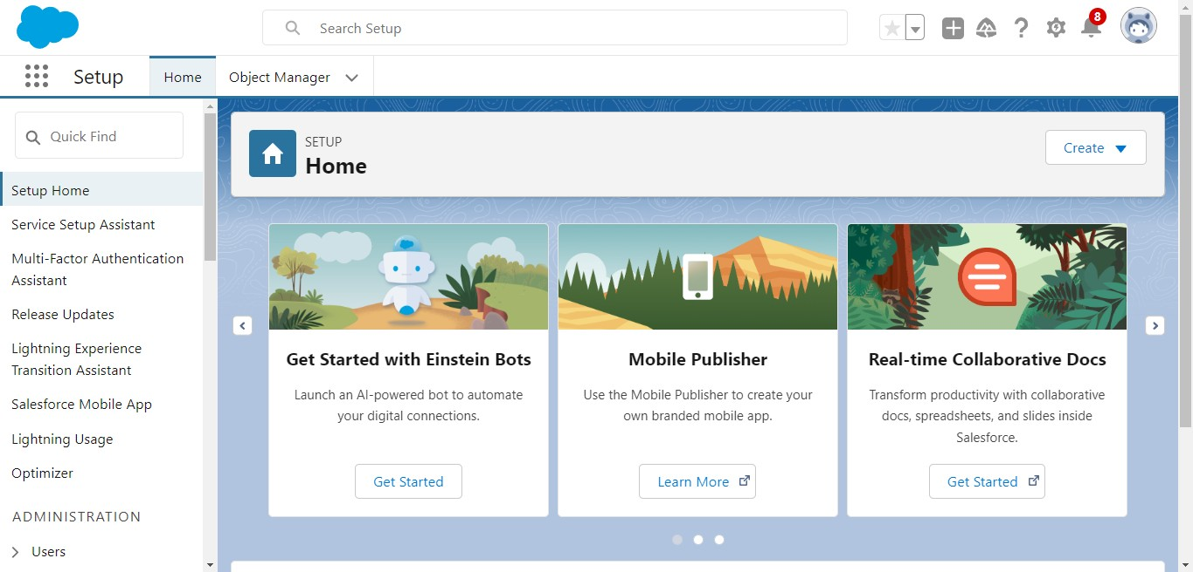

Milestone 2 – Objects:
Activity 1: Creating Student Object:
The purpose of creating the Student custom object is to store and manage information about students such as their personal details, contact information, and enrollment status.

To create the Student object:

Go to the Setup page.

Click on Object Manager.

Click on Create → Custom Object.

Enter the details as below:
  - Label: Student
  - Plural Label: Students
  - Object Name: Student
  - Record Name: Student Name
  - Data Type: Text
  - Under Optional Features, select:
  - Allow Reports
  - Allow Activities (optional but recommended) 9. Track Field History (optional, if you want)
10. Under Search Status, select: 11. Allow Search
12. Click Save.

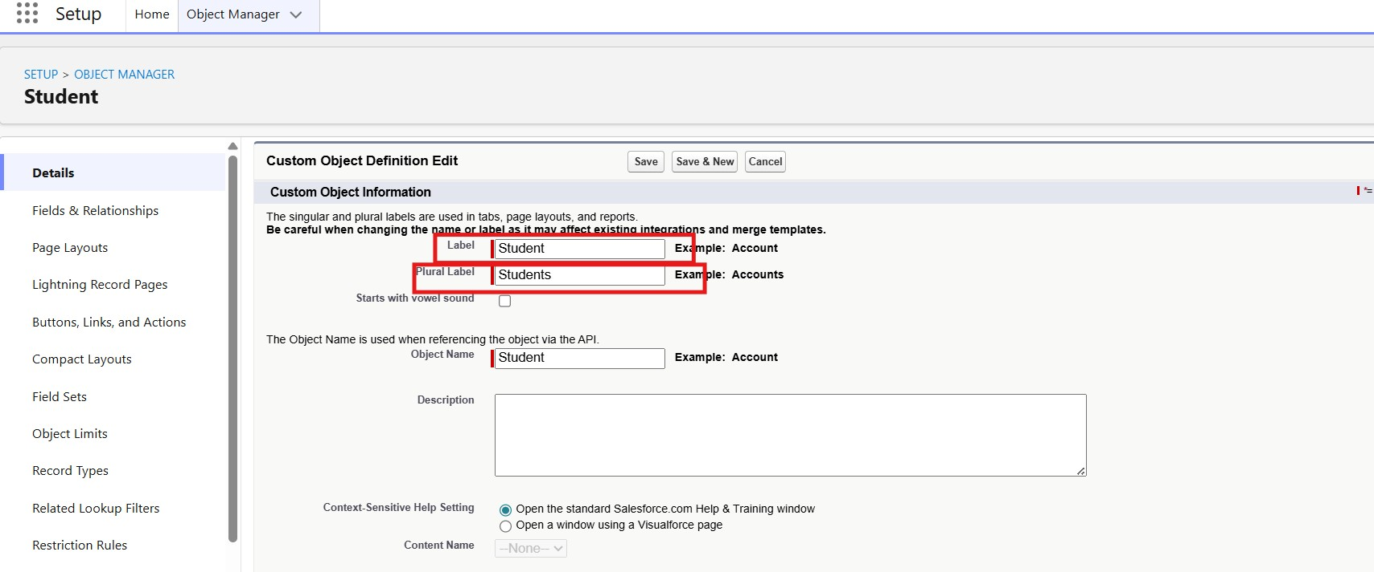

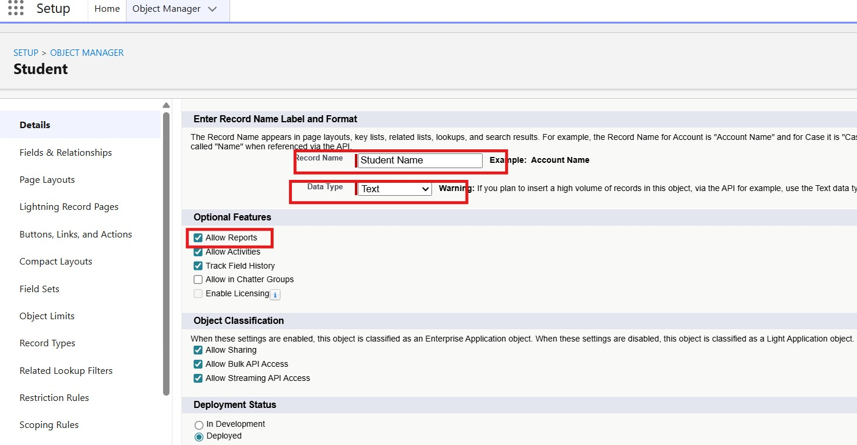

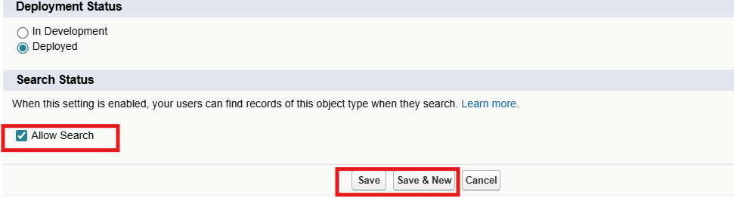

In the same way Create Courses, Instructors, and Enrolments objects

Milestone 3 - Fields:

Table 1: Student Object Fields:

Field Label |  | Data Type
Student Name |  | Text  (Standard)
Email |  | Email
Phone |  | Phone
Date of Birth |  | Date
Student Status |  | Picklist
Address |  | Text Area
Field Label | Data Type
Course  Name | Text  (Standard)
Category | Picklist
Duration | Number/Text
Course Fee | Currency
Description | Text Area

Table 2: Course Object Fields:

Table 3: Instructor Object Fields:

Field Label | Data Type
Instructor  Name | Text  (Standard)
Instructor  Code | Text
Expertise | Picklist
Phone | Phone
Email | Email

Table 4: Enrollment Object Fields:

Field Label | Data Type
Student | Lookup  (Student)
Course | Lookup (Course)
Instructor | Lookup  (Instructor)
Enrollmen t Date | Date
Enrollmen  t Status | Picklist
Fees Paid | Checkbox
Total  Amount | Currency
Comment  s | Text Area

Milestone 4 – Create Relationships:
- Activity 1: Create Lookup from Enrollment to Student:
1.
Go to Setup → click Object Manager.
- Type Enrollment in Quick Find → click Enrollment__c object.
- Click Fields & Relationships → click New.
- Select Lookup Relationship → click Next.
- For Related To, select Student__c → click Next.
- Enter Field Label: Student (API Name: Student__c).
- Click Next through Field-Level Security and Layout options (ensure it’s visible and added to layout).
- Click Save.
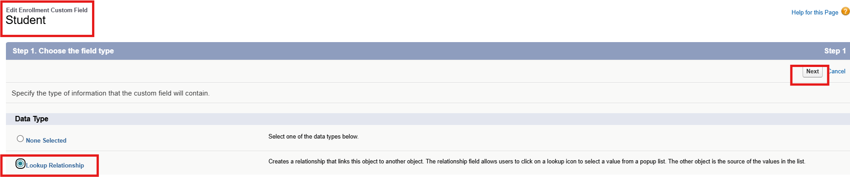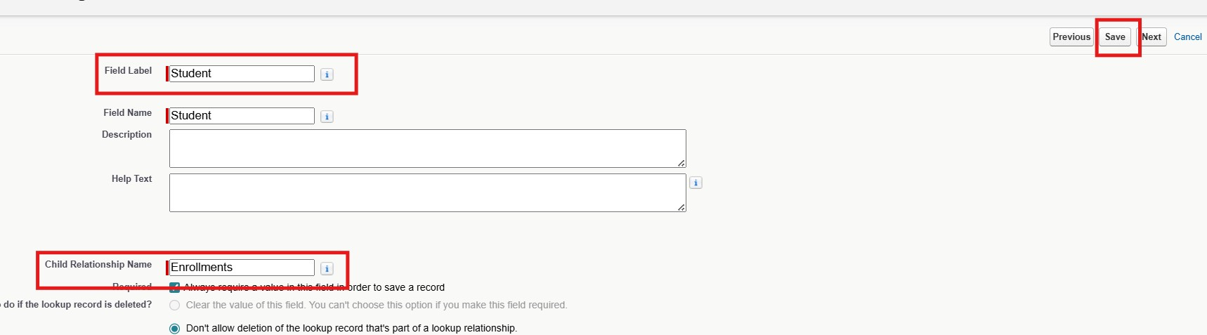

Activity 2: Create Lookup from Enrollment to Course
Purpose:
To link each Enrollment to a Course.

Steps:
- Go to Setup → Object Manager → Enrollment__c.
- Click Fields & Relationships → New.
- Select Lookup Relationship → Next.
- Related To: select Course__c → click Next.
- Field Label: Course (API Name: Course__c).
- Click Next (set visibility and layout) → Save.
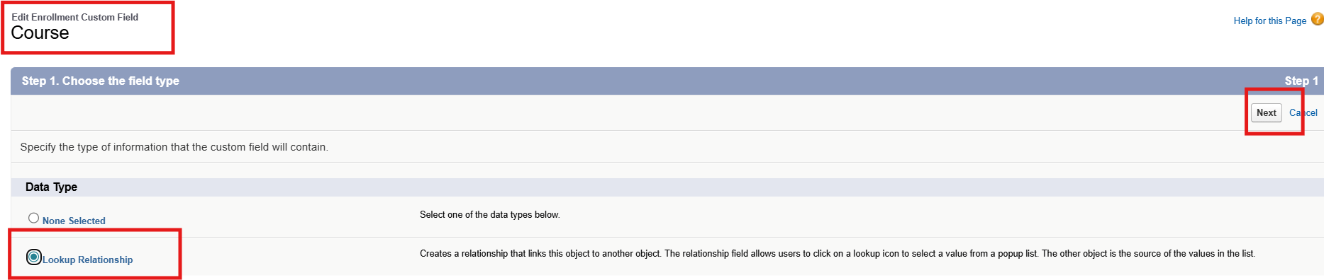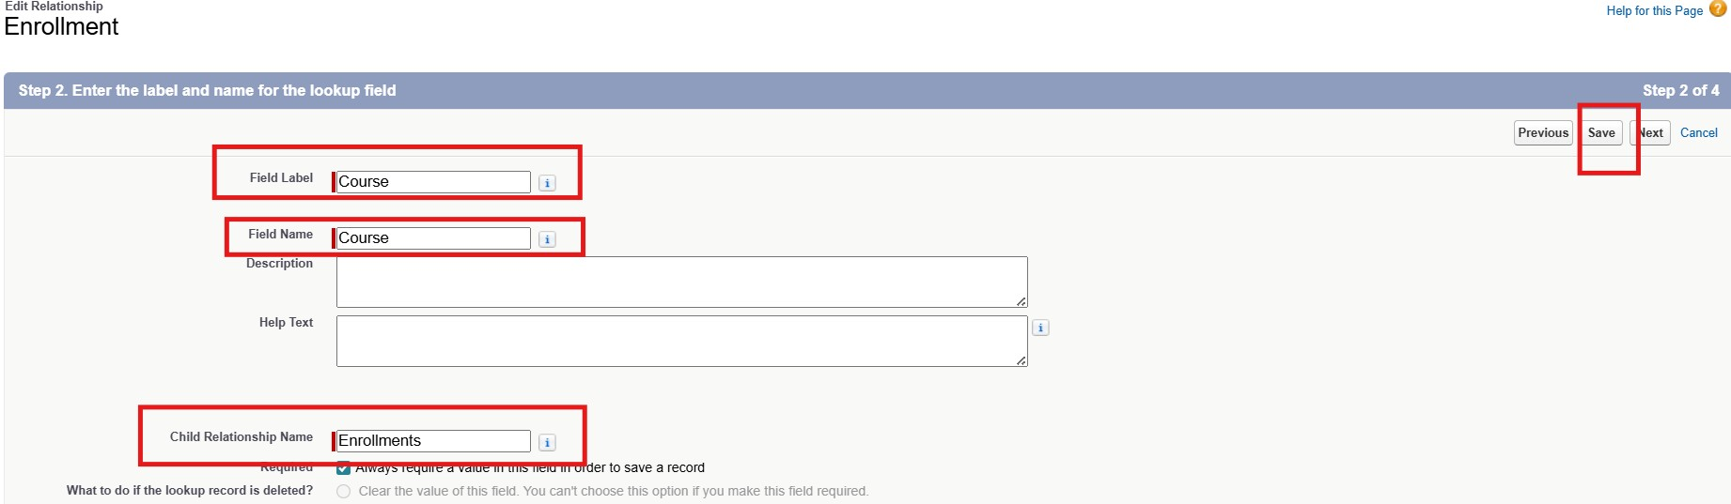
Activity 3: Create Lookup from Enrollment to Instructor:
Purpose:
To store which Instructor is assigned to a particular Enrollment.

Steps:
- Go to Setup → Object Manager → Enrollment__c.
- Click Fields & Relationships → New.
- Choose Lookup Relationship → Next.
- Related To: select Instructor__c → Next.
- Field Label: Instructor (API Name: Instructor__c).
- Complete Field-Level Security and Page Layout options → Save
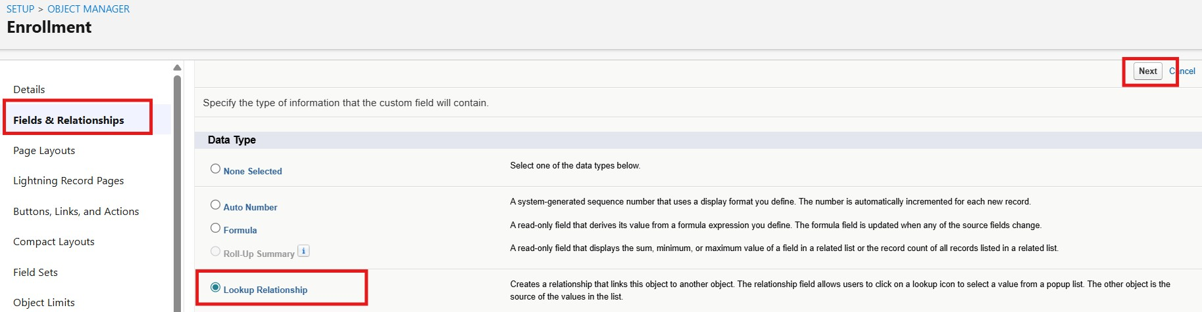
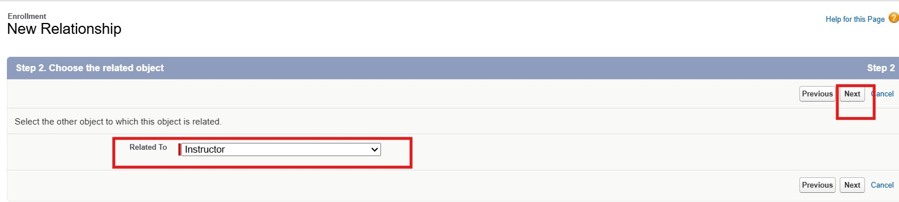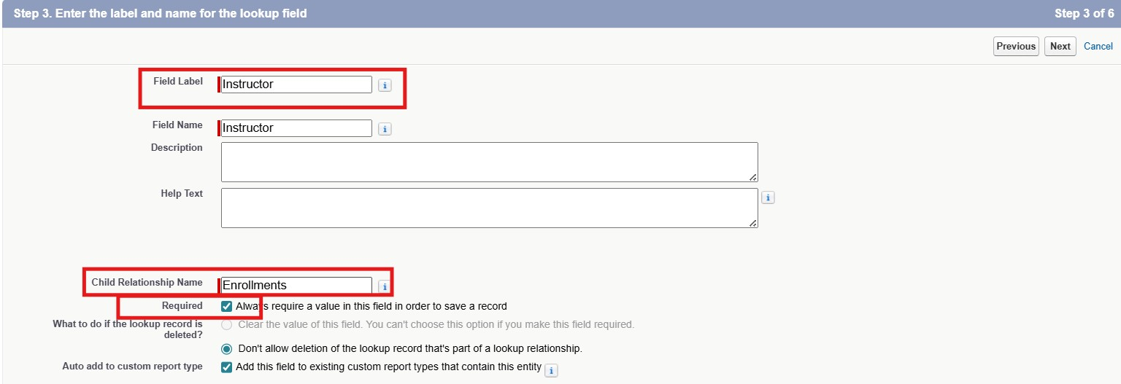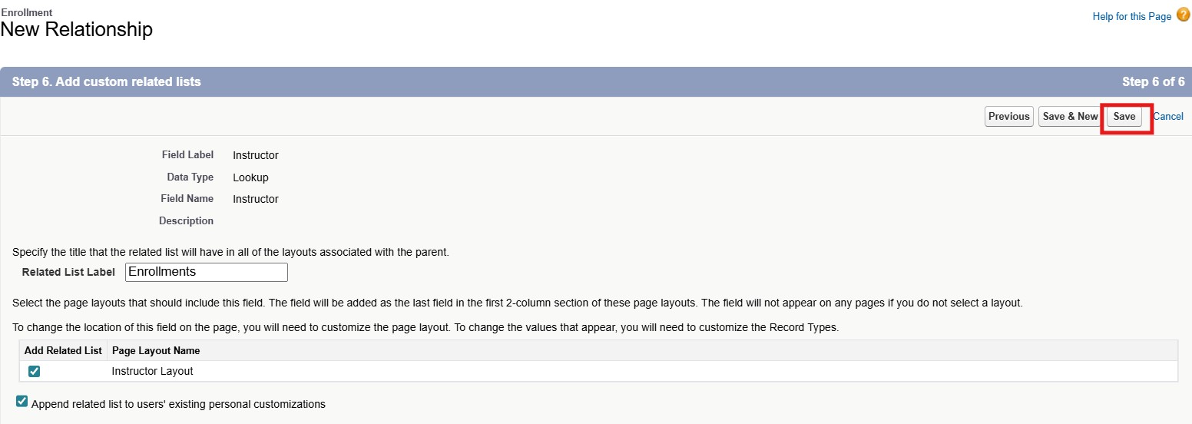

Milestone 5 – Validation Rules:

Activity 1: Student Email Domain Validation
Purpose:
To ensure students use only allowed institutional email addresses.

Steps:

Go to Setup → Object Manager → Student__c.
Click Validation Rules → New.
Rule Name: Student_Email_Domain_Validation.
Error Condition Formula: (example for @student.edu)
● NOT(CONTAINS(Email__c, "@student.edu"))

Error Message: Email must be a valid student institutional email.
Error Location: Field → Email__c. Click Save.
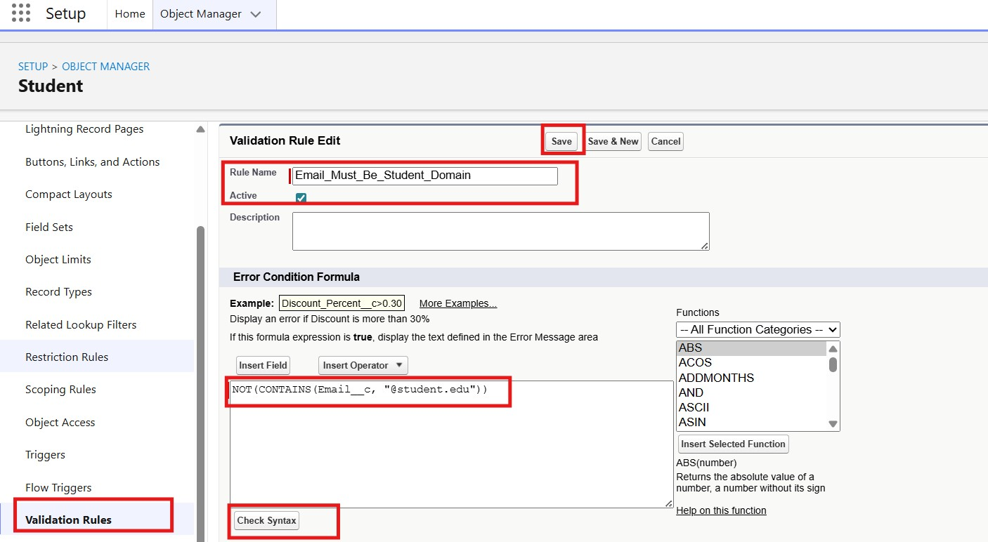
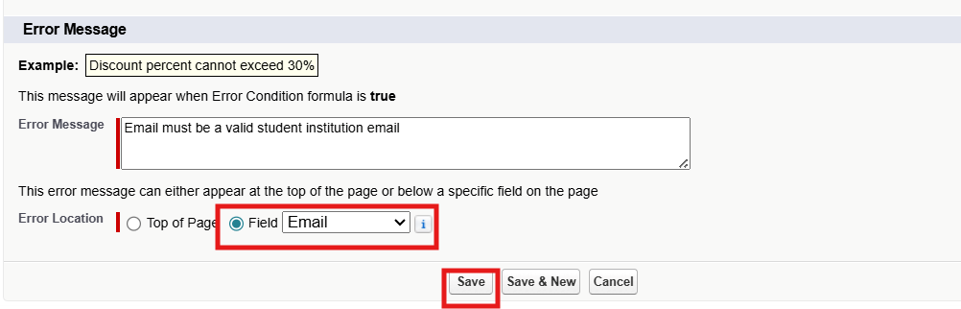

Activity 2: Fees Must Be Paid Before Approval

Purpose:
Prevent Enrollment from being approved until fees are paid.

Steps:

- Go to Setup → Object Manager → Enrollment__c.
- Click Validation Rules → New.
- Rule Name: Fees_Must_Be_Paid_Before_Approval.
- Error Condition Formula:
AND(
ISPICKVAL(Enrollment_Status__c, "Approved"),
Fees_Paid__c = FALSE
)
5.Error Message: Fees must be paid before approving an enrollment.
6.Error Location: Top of Page (or field as needed).
Click Save.
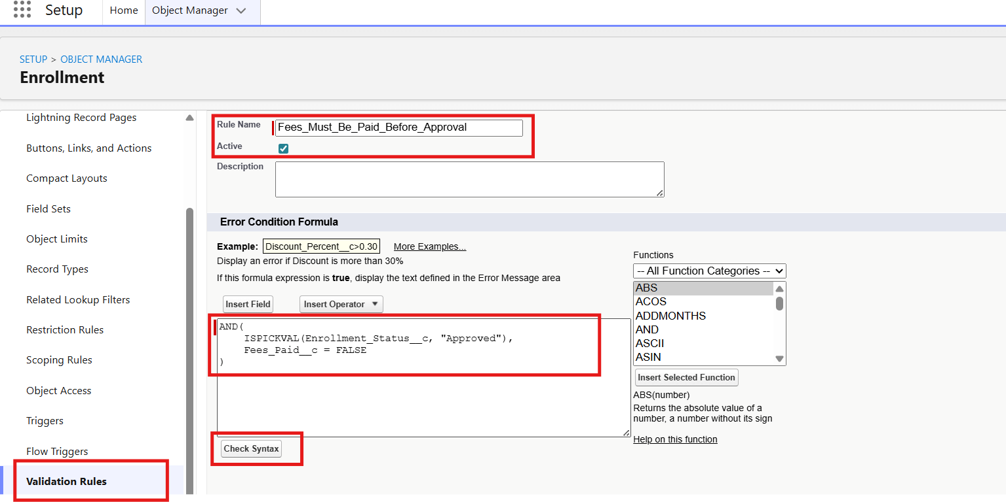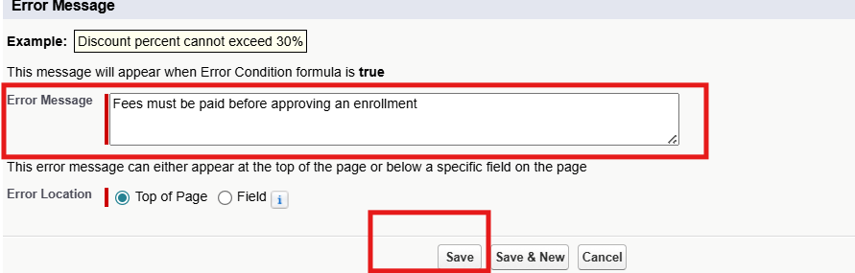

Milestone 6 – Approval Process

Activity 1: Create Approval Process for Enrollment Requests

Purpose:
Route Enrollment requests to Training Manager for approval or rejection.

Steps:

- Go to Setup → Approval Processes → select Enrollment__c.
- Click Create New Approval Process → Use Standard Setup.
- Process Name: Approval_Enrollment_Request.
- Entry Criteria: Enrollment_Status__c = "Requested".
- Save and configure steps.
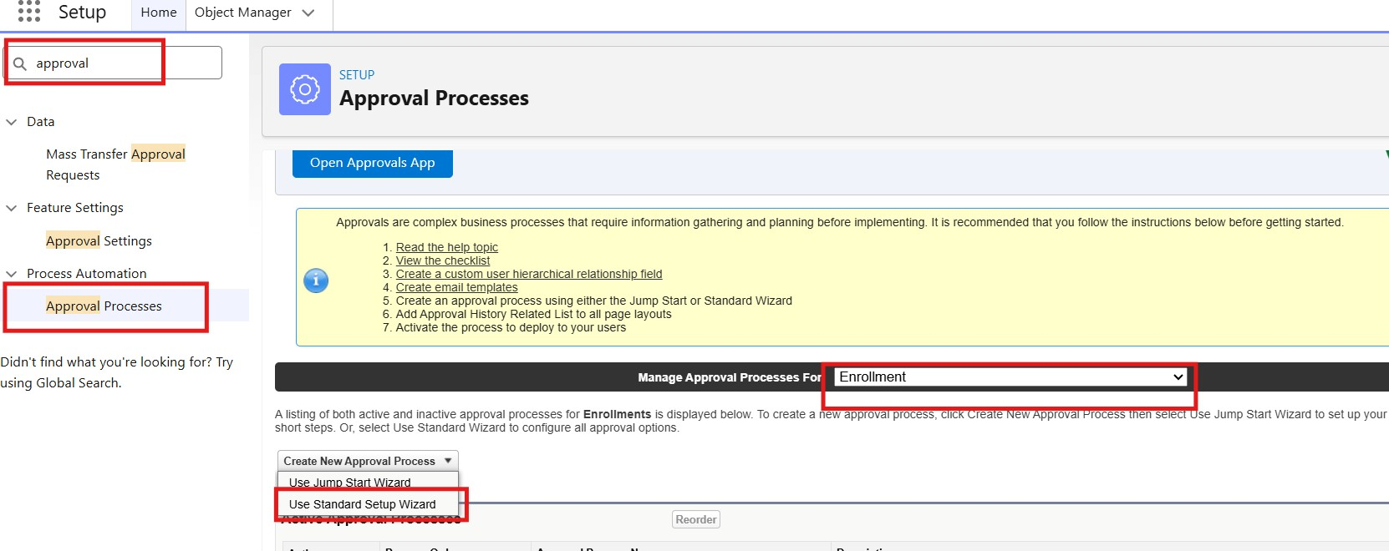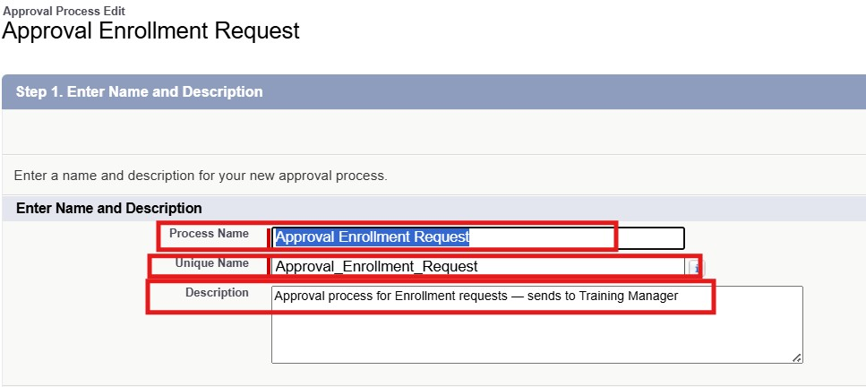
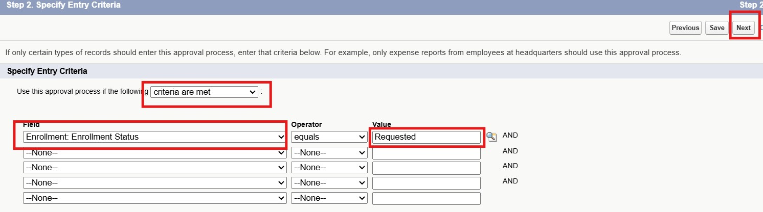
- Add Approval Step:
- Approver: specific Training Manager user.
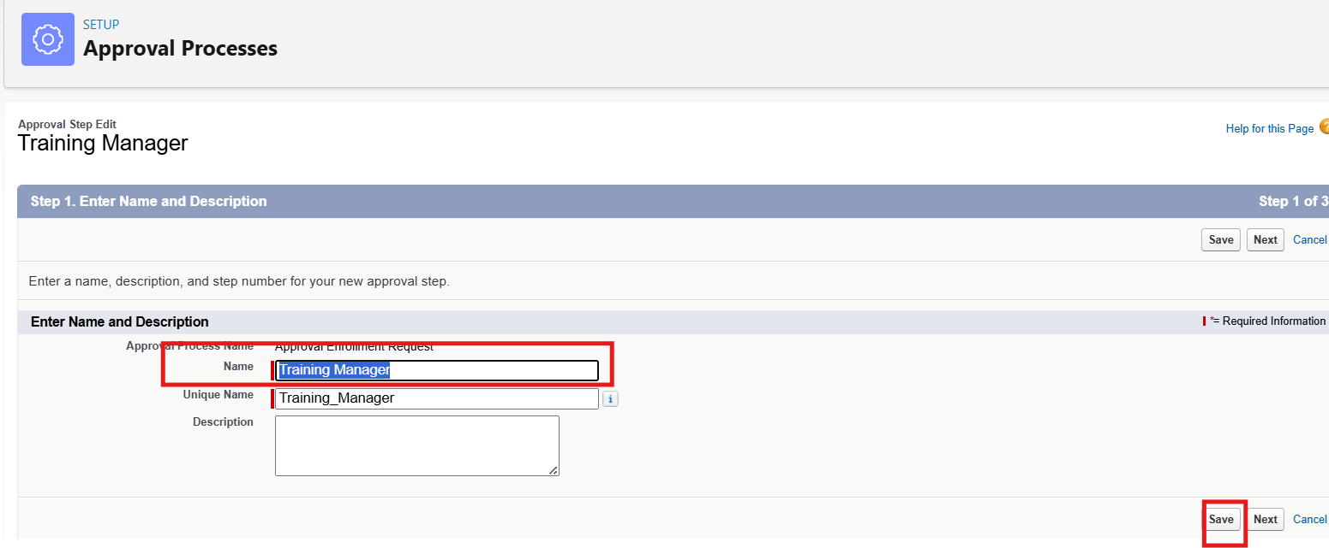
- Under Final Approval Actions:
- Add Field Update to set Enrollment_Status__c = "Approved".
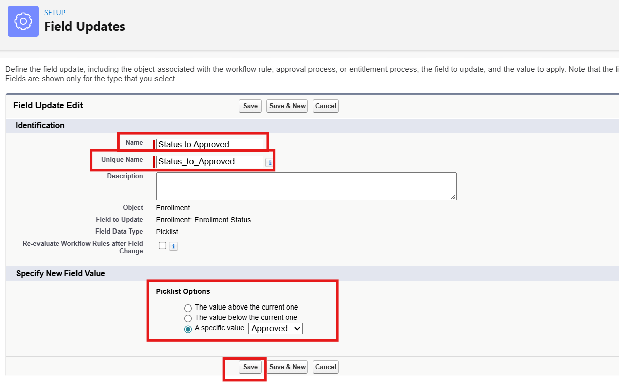
- Under Final Rejection Actions:
- Add Field Update to set Enrollment_Status__c = "Rejected".
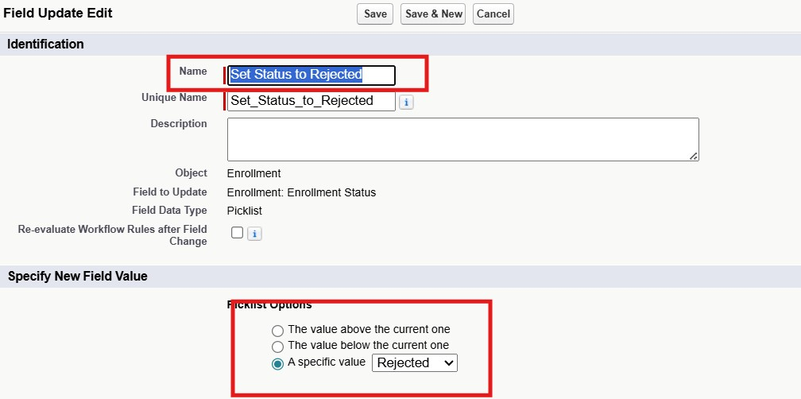
- Add Email Alert to send rejection email to student.
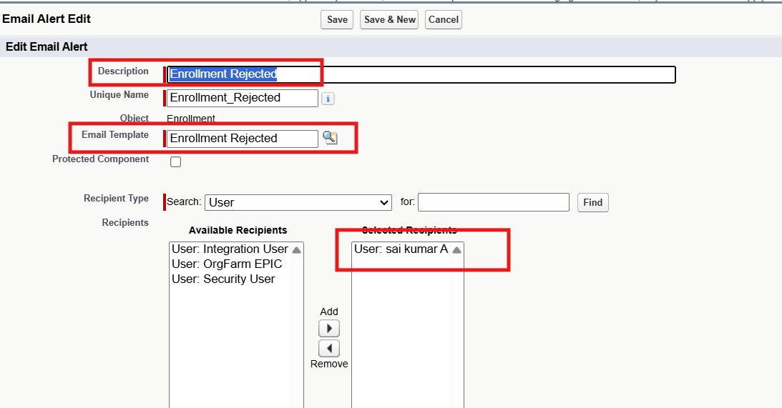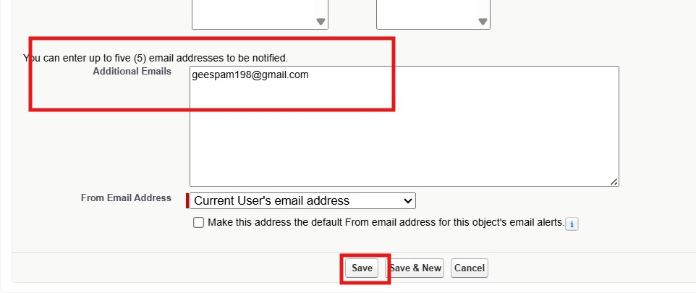
- Activate the approval process.

Milestone 7- Tabs

Activity 1: Creating a Tab for the Student Object:
Go to Setup.
- In the Quick Find box, type Tabs.
- Under Custom Object Tabs, click New.
- Select Student from the object list.
- Choose a tab style (icon).
- Click Next, assign it to all profiles, and then click Save.

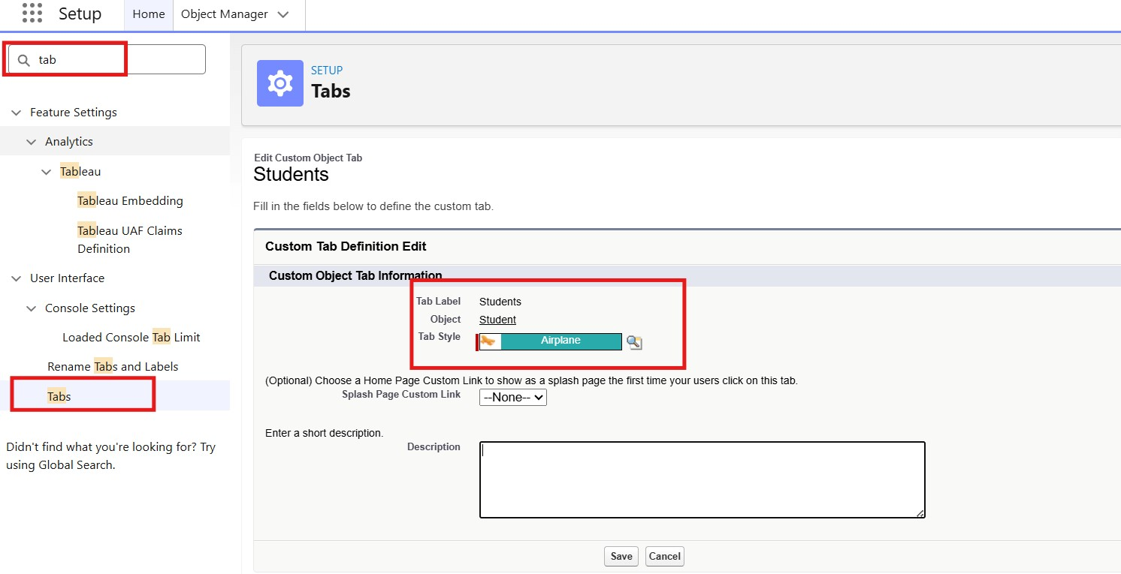

Activity 2: Creating Remaining Tabs

Now create the Tabs for the remaining Objects, they are “Courses, Instructors, Enrollment”.
Follow the same steps as mentioned in Activity -1

Milestone 8 - The Lightning App

Activity 1: Creating the Lightning Application for the Project
Navigate to Setup.

Enter App Manager in the Quick Find search box.
Click New Lightning App.
Provide the app details:
App Name: Student Enrollment & Course Management
Developer Name auto-fills
Description: Optional, but can describe the purpose of the app Click Next and choose the following settings:
App Branding (optional): Add logo or select color theme
Navigation Style: Choose Standard Navigation
Click Next and assign the app to specific profiles (e.g., Admin, Enrollment Officer, Instructor).
Click Next to select the items (tabs) to be included in the app. Add:
- Student
- Course
- Instructor
- Enrollment
- Reports
- Dashboards
- Home
- Tasks
Click Next and review the app settings.
Finally, click Save & Finish.

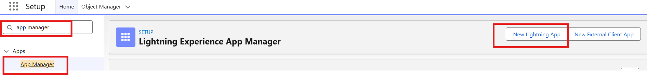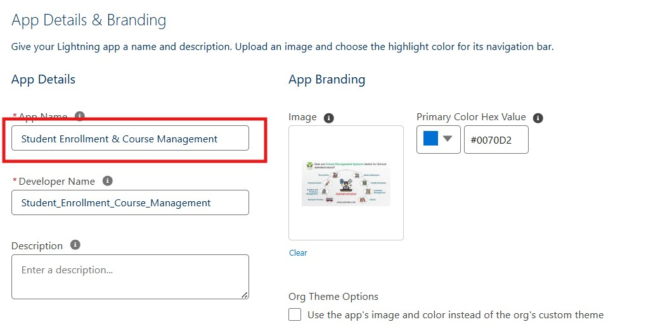

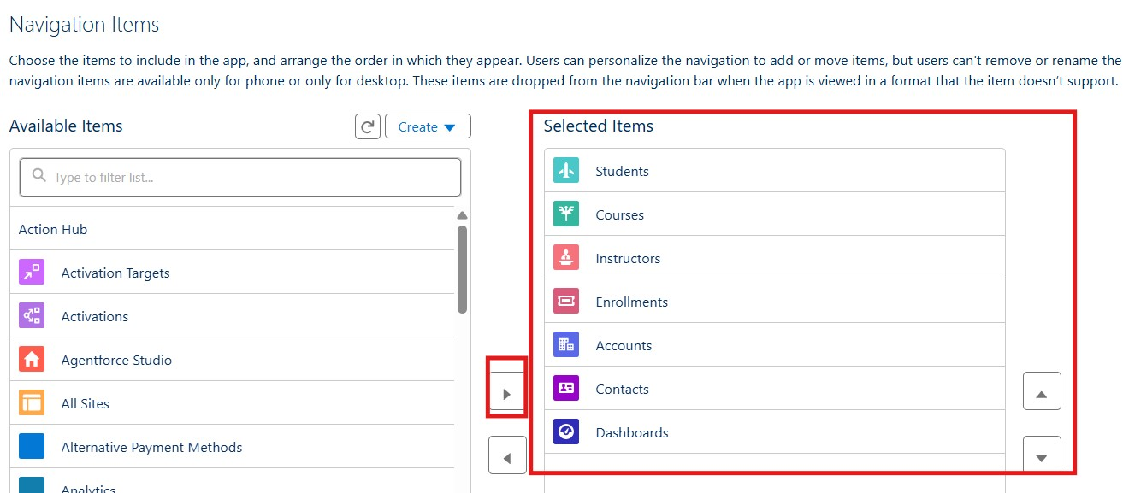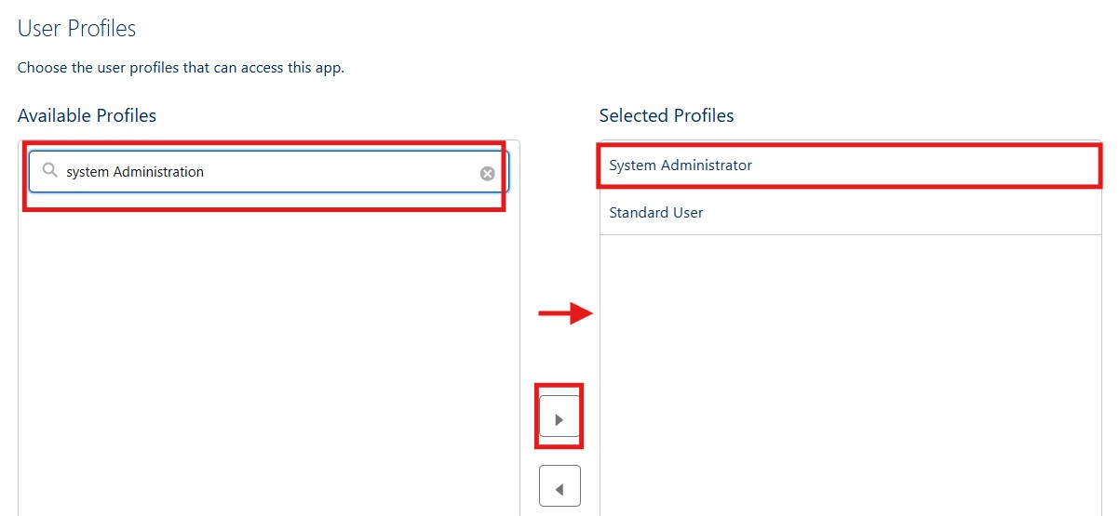
Milestone 9 – Page Layouts and Record:

Activity 1: Create Record Types for Enrollment:

Purpose:
To separate New Enrollment vs Re-Enrollment processes.
Steps:
1.Go to Setup → Object Manager → Enrollment__c.
2.Click Record Types → New.
3.For the first record type:
- Existing Record Type: Master
- Record Type Label: New Enrollment
- Enable for required profiles (Admin, Enrollment Officer). ● Select the default Page Layout → Save & New.
4.For the second record type:
- Record Type Label: Re-Enrollment ● Enable for same profiles.
- Select the default Page Layout → Save.
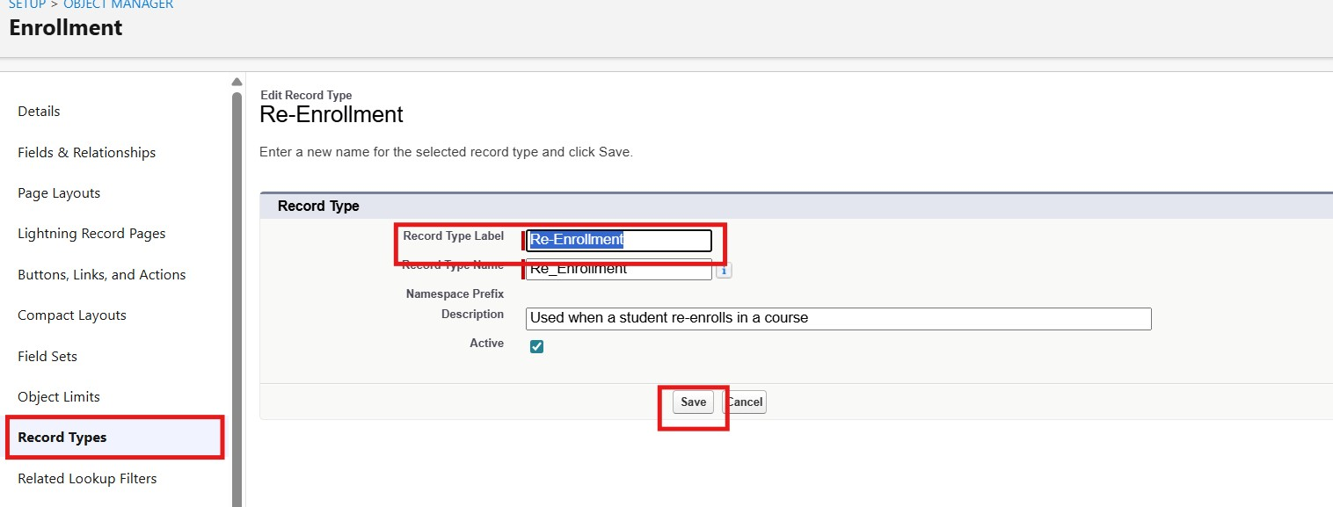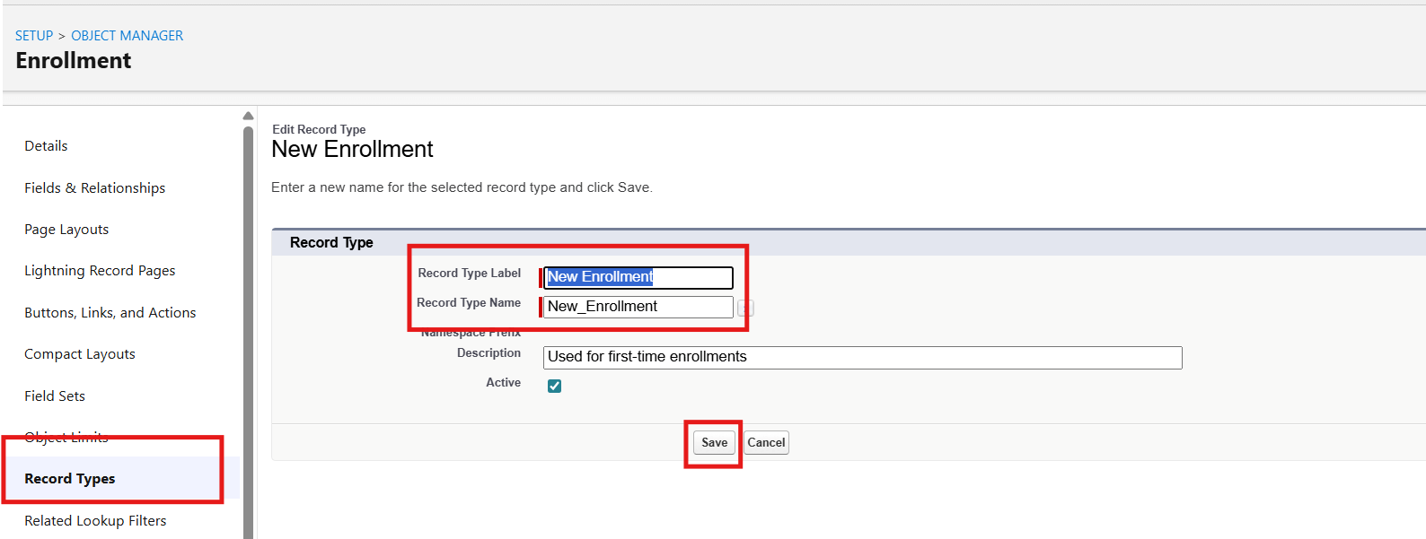

Activity 2: Separate Page Layo Createuts for Each Enrollment Record Type

Purpose:
To show different fields for New Enrollment vs Re-Enrollment.

Steps:

1.Enrollment__c object → click Page Layouts.
2.Click New to create a layout for New Enrollment:
- Clone from existing Enrollment Layout → name it New Enrollment Layout → Save.
- Keep fields relevant for first-time enrollment: Student, Course, Instructor, Enrollment Date, Status, Fees, etc.
- Remove unnecessary re-enrollment fields if any. ● Click Save.
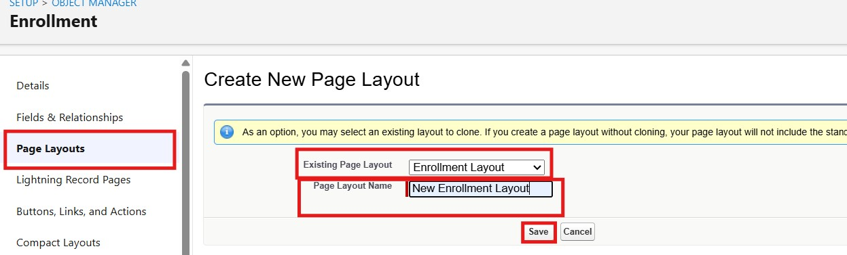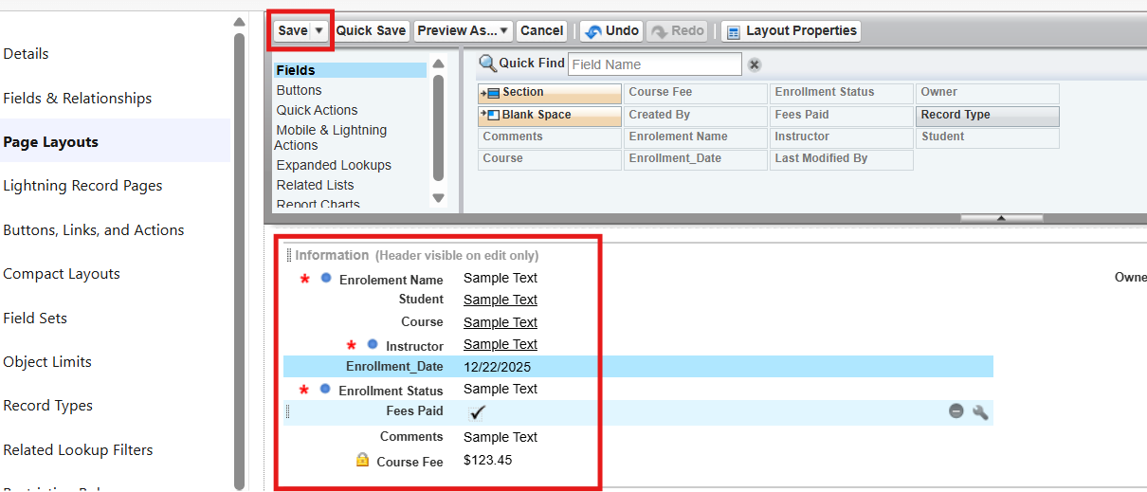

3.Again, click New to create Re-Enrollment Layout:
- Clone existing layout → name it Re-Enrollment Layout → Save.
- Include fields like previous Enrollment reference (if any), Re-Enrollment Reason, Status, Fees, etc. ● Click Save.
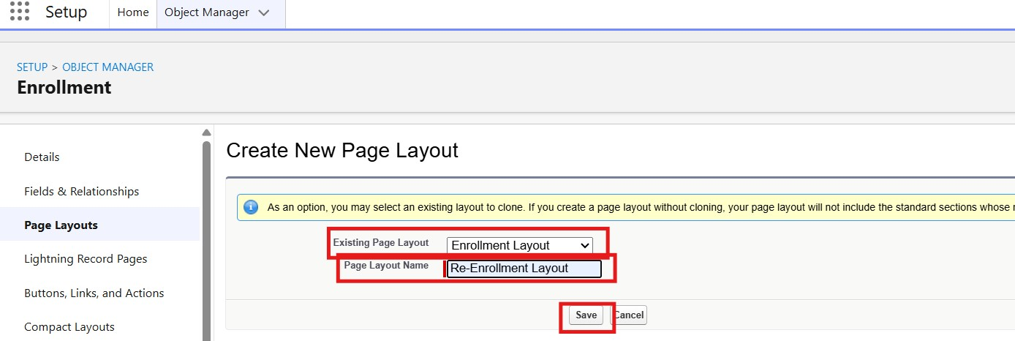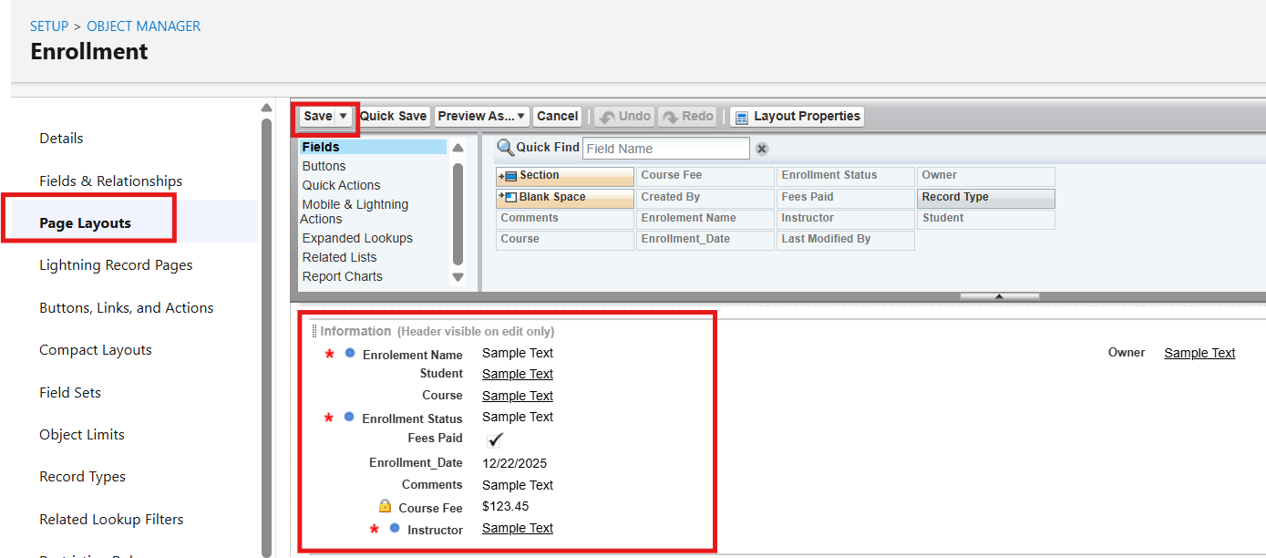

4.Click Page Layout Assignment → Edit Assignment.
5.For each profile and record type:

- New Enrollment → use New Enrollment Layout.
6.Re-Enrollment → use Re-Enrollment Layout.
Click Save.

Activity 3: Enrollment R Addelated Lists to Parent Objects:

Purpose:
To see all Enrollments from Student, Course, and Instructor records. a) Student → Enrollment Related List Go to Setup → Object Manager → Student__c.
Click Page Layouts → open the main layout. In the palette, select Related Lists.
Drag Enrollments related list onto the layout. Customize columns if needed → Save. b) Course → Enrollment Related List
Go to Object Manager → Course__c → Page Layouts.
Open layout → add Enrollments related list.
Save.
c) Instructor → Enrollment Related List
Go to Object Manager → Instructor__c → Page Layouts.
Open layout → add Enrollments related list. Save.

Milestone 10 – Automation with Flow

Activity 1: Auto-Populate Enrollment Date (Record-Triggered Flow)

Purpose:
Set Enrollment_Date__c to today when Enrollment is created.

Steps:

- Go to Setup → Flows → New Flow.
- Select Record-Triggered Flow → Create.
- Object: Enrollment__c.
- Trigger: A record is created.
- Optimize for Actions and Related Records → Done.
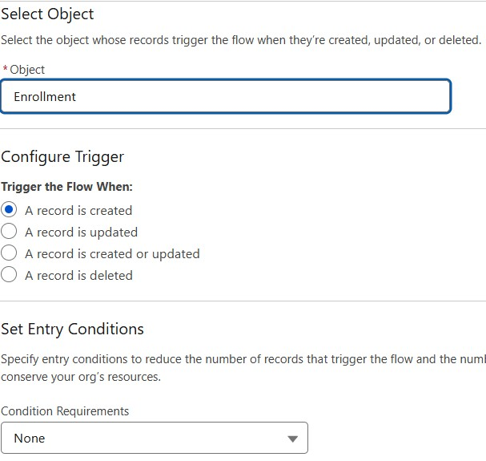
- Add Update Records element: ● Label: Set Enrollment Date.
- Use record that triggered the flow.
- Field: Enrollment_Date__c → Value: $Flow.CurrentDate.
7.Save as SetEnrollmentDate → Activate.
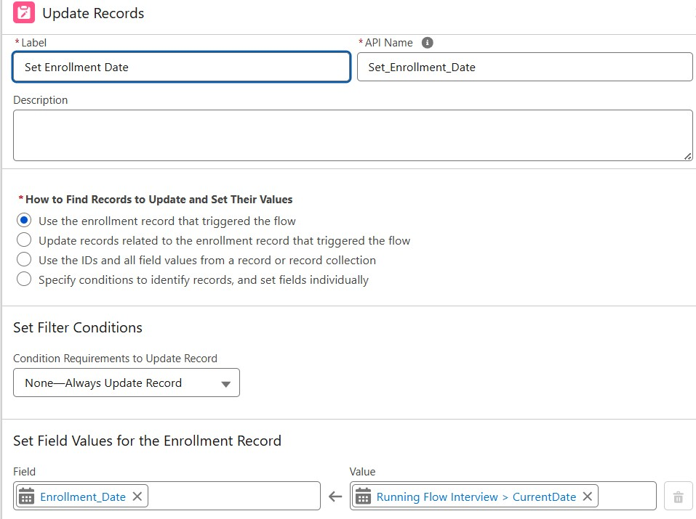

Activity 2: Send Email When Enrollment Approved

Purpose:
When Enrollment_Status__c = Approved, send email, alert admin, and set Student to Active.
Steps (high level for document):

- Create Email Template and Email Alert for student notification.

- Go to Flows → New → Record-Triggered Flow.
- Object: Enrollment__c, Trigger on update.
- Condition: Enrollment_Status__c Equals "Approved".
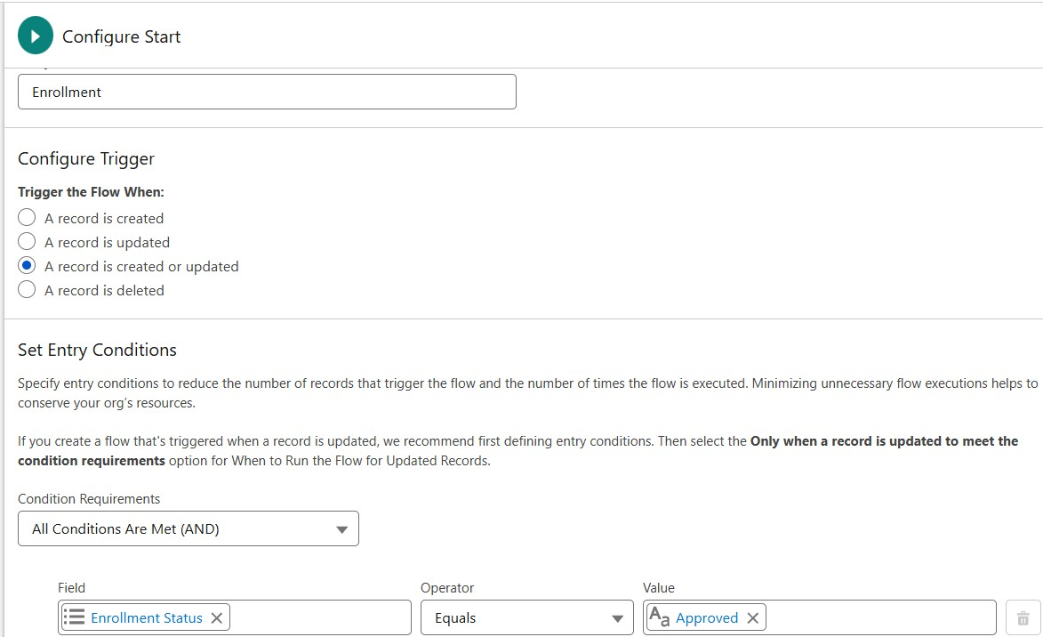
- Add Get Records to fetch related Student__c.
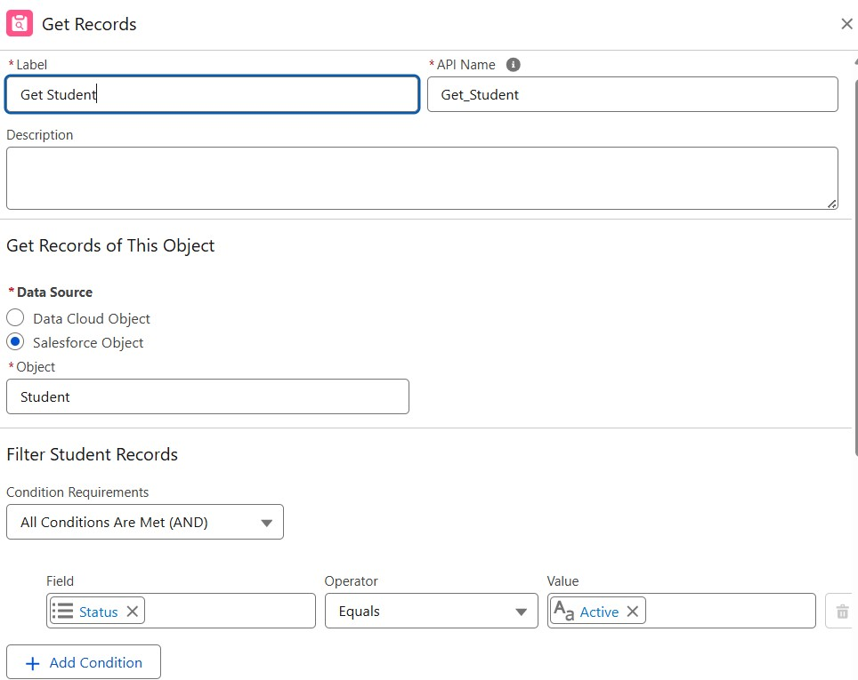
- Add Action (Email Alert) to send email to student.
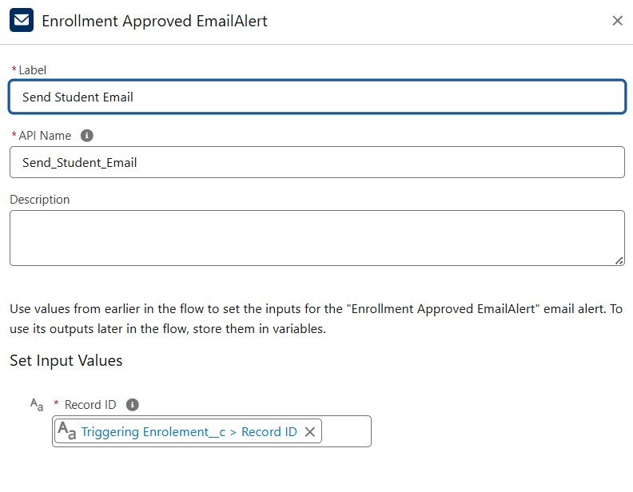
- Add Action to notify Admin if needed.
- Add Update Records to set Student__c.Status__c = "Active".
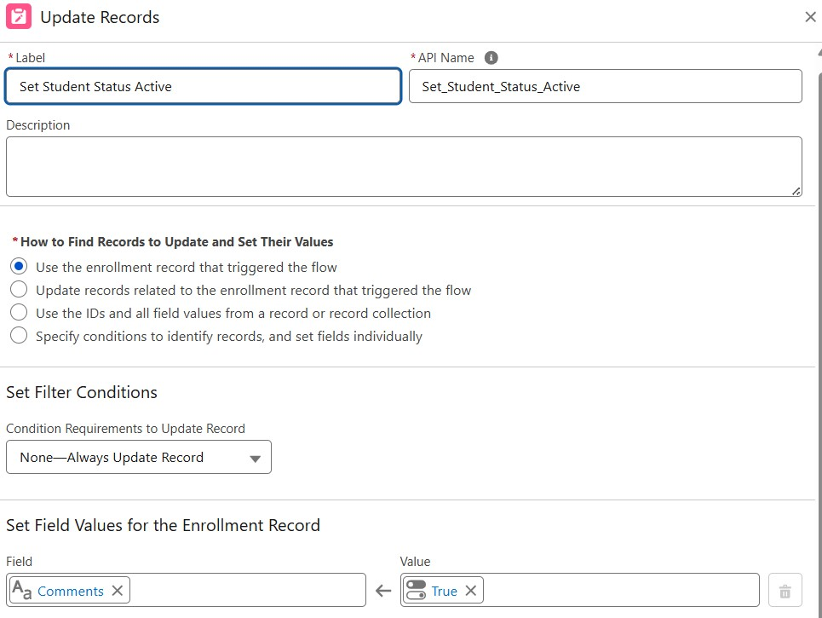
- Save as Enrollment Approved Action → Activate.

Activity 3: Auto-Assign Instructor Based on Course Category

Purpose:
Assign Instructor automatically based on Course category.

Rules:

Technical → Instructor A
Language → Instructor B
Non-Technical → Instructor C

Steps:

- Prepare Instructor__c records with codes (e.g., INSTR_A, INSTR_B, INSTR_C).
- Create Record-Triggered Flow on Enrollment__c (created/updated).
- Add Get Records to fetch related Course__c.
- Add Decision element on Course__r.Category__c:
- Technical / Language / Non-Technical outcomes.
- For each outcome:
- Get Instructor record (A/B/C) based on code or name.
- Update Records: set Instructor__c = Get_Instructor_X.Id.
- Save as AutoAssign_Instructor → Activate.
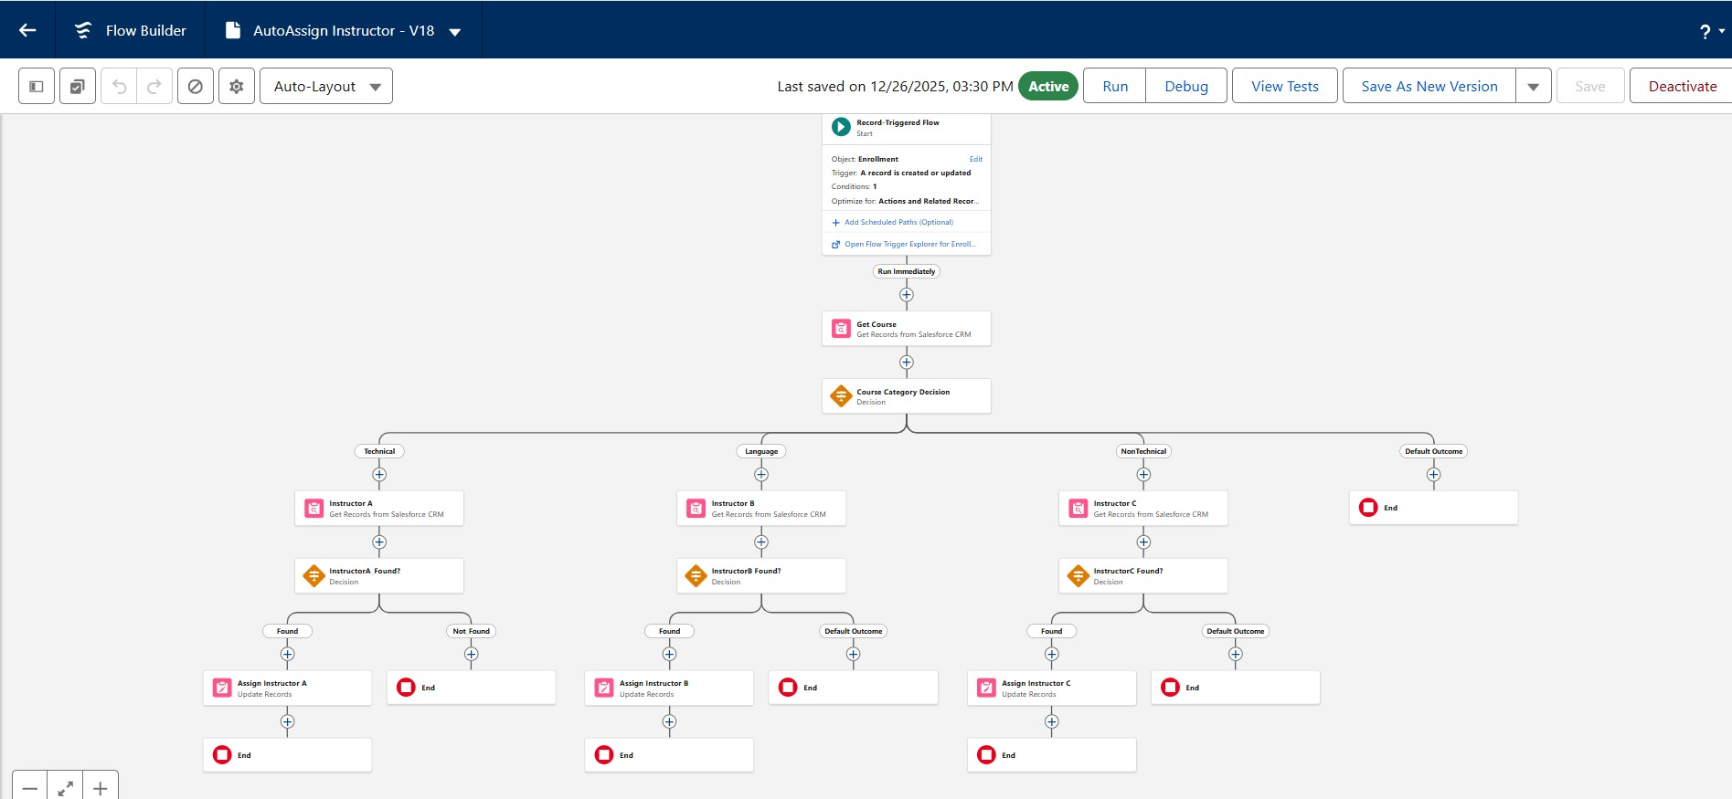

Activity 4: Auto-Create Task for Follow-Up

Purpose:
When Enrollment is “Requested”, create a follow-up task for Admin.

Steps:

- Create Record-Triggered Flow on Enrollment__c.
- Trigger: Record created or updated; condition Enrollment_Status__c = "Requested".
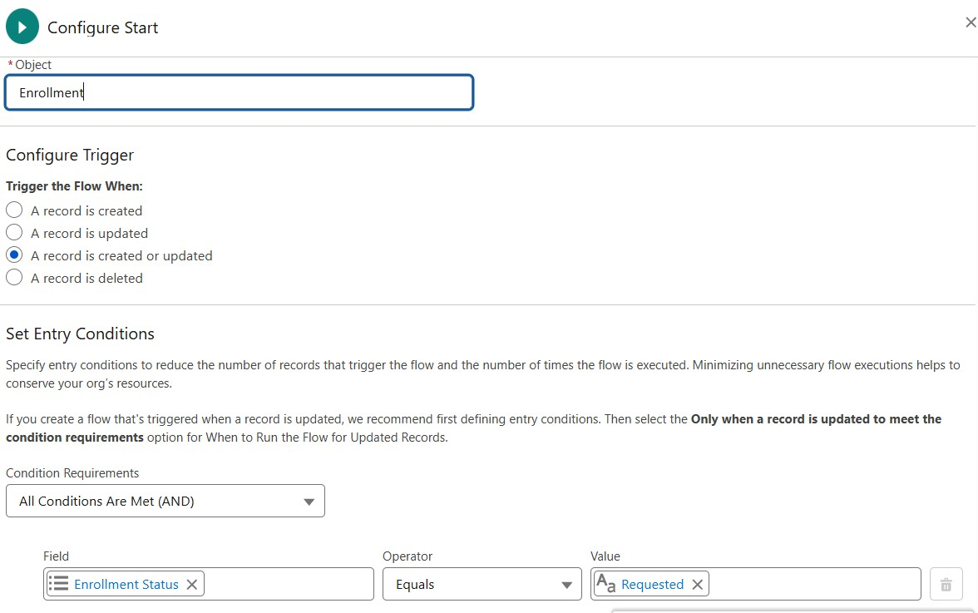
- Add Get Records to fetch Admin user (by Username / Profile).
- Add Formula (Date): TODAY() + 2 for due date.
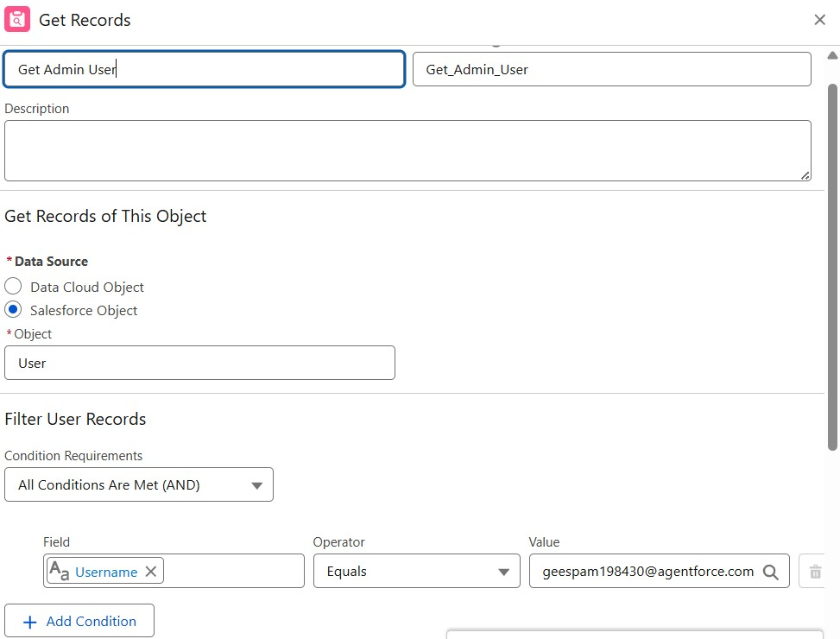
- Add Create Records for Task:
- Subject: Follow up on enrollment request.
- OwnerId: Admin user Id.
- WhatId: Enrollment Id.
- ActivityDate: formula Today + 2.
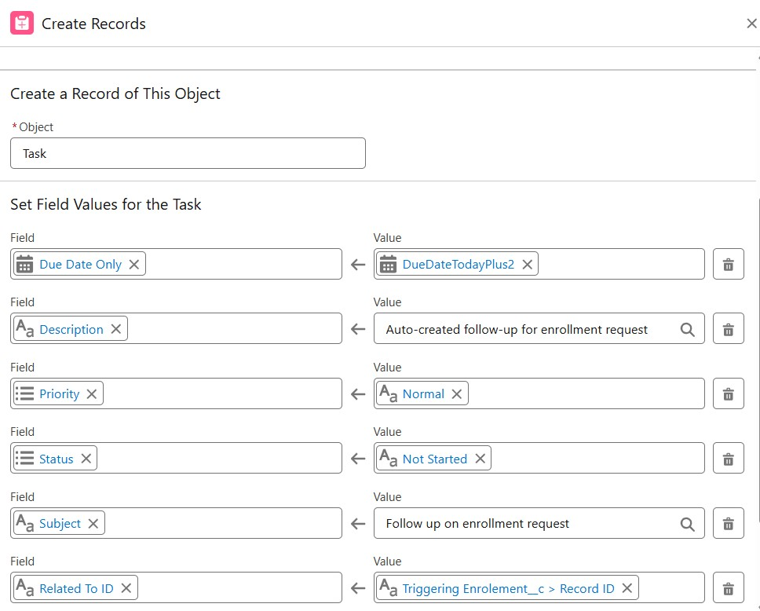
- Save as Create_Followup_Task → Activate.
Milestone 11 – Reports:

Activity 1: Create “Students by Status” Report

1.Go to Reports → New Report.
2.Report Type: Students.
3.Group rows by Status__c.
4.Add columns as needed (Name, Email, Phone).
5.Save as Students by Status.
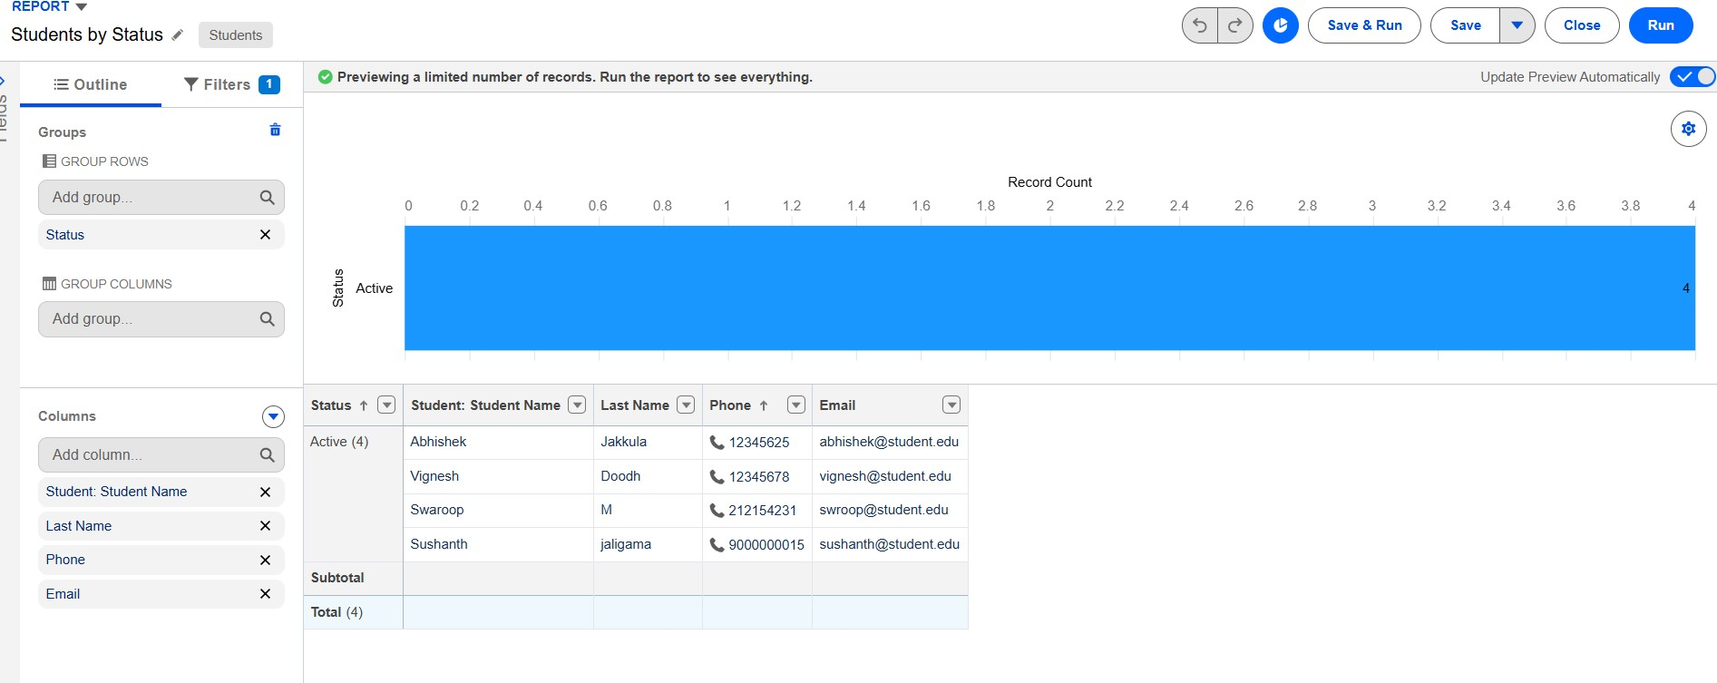

Activity 2: Create “Enrollments by Course” Report

1.New Report → Report Type: Enrollments.
2.Grouprows by Course__r.Name.
3.Show Record Count per course.
4.Save as Enrollments by Course
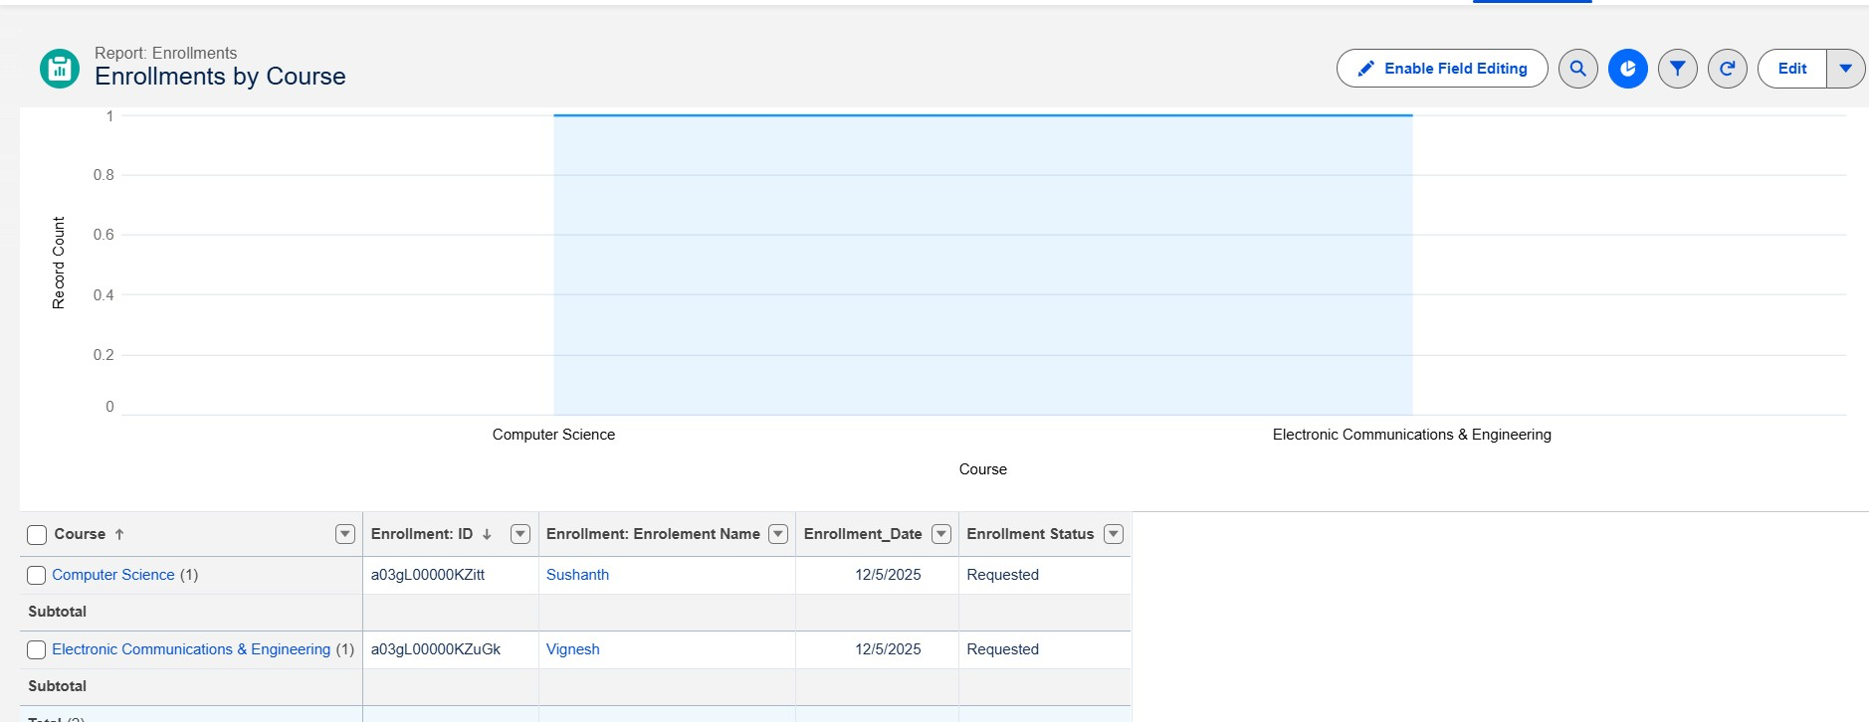

Activity 3: Create “Pending Enrollment Approvals” Report

- New Report → Enrollments report type.
- Filter: Enrollment_Status__c = "Requested".
- Add columns (Student, Course, Owner, Created Date).
- Save as Pending Enrollment Approvals.
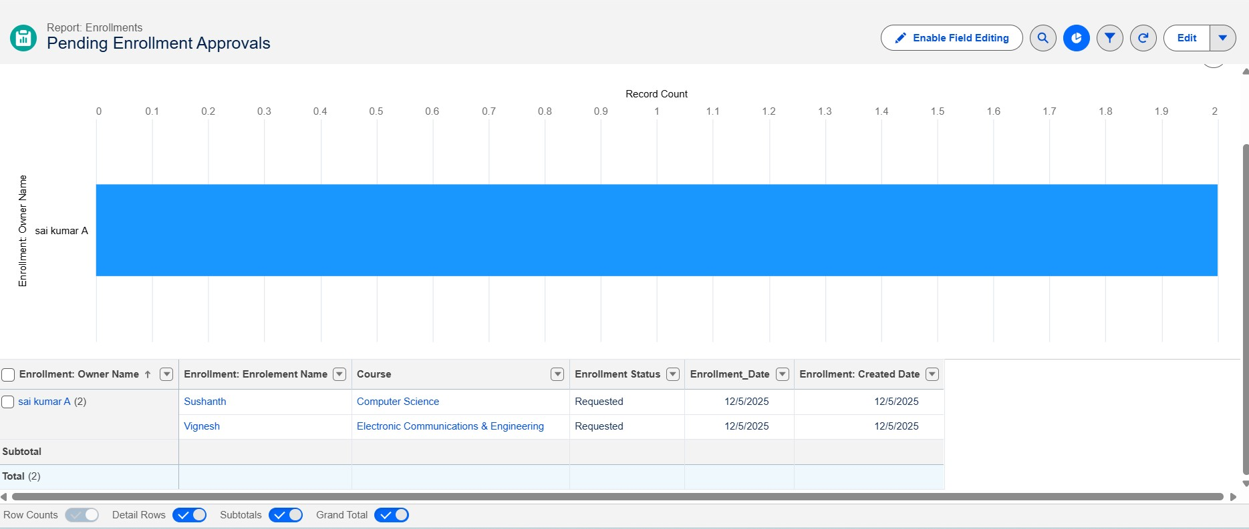

Activity 4: Create “Revenue Report (Fees Paid)” Report

1.New Report → Enrollments report type.
2.Filter: Fees_Paid__c = TRUE.
3.Group by Course__r.Name.
4.Summarize Course_Fee__c or similar fee field.
5.Save as Revenue Report – Fees Paid.
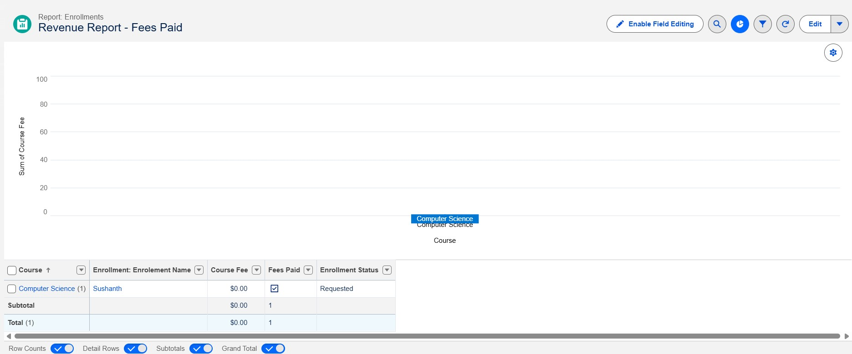
Milestone 12 – Dashboards:

Activity 1: Create “Student Managemet Dnashboard”
Steps:
- Go to Dashboards → New Dashboard.
- Name: Student Management Dashboard.
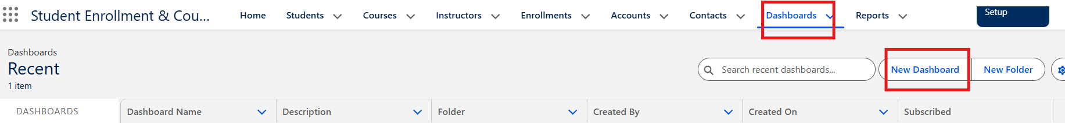
- Select folder → Create.
- Select new Dashboard folder and Save.
Add components:
- Donut Chart → using Students by Status report.
- Bar Chart → using Enrollments by Course report.
- Gauge → using Revenue Report – Fees Paid (sum of revenue field).
- Table → using Pending Enrollment Approvals report.

4. Arrange components on canvas.
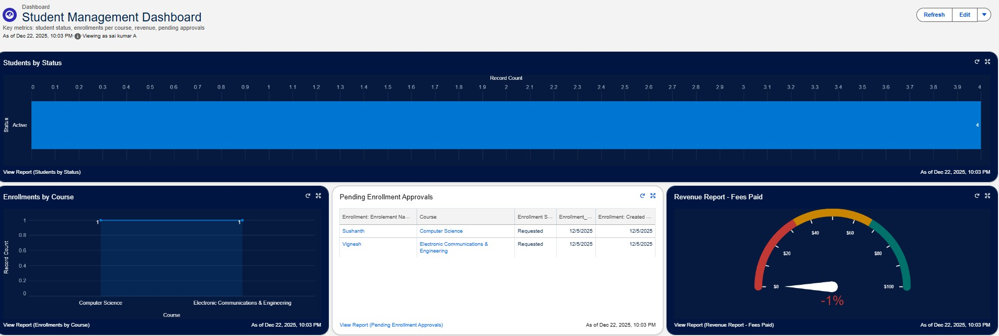 Click Save → Done.

Milestone 13 – Security Setup

Activity 1: Configure Profiles
):
1. Go to Setup → Profiles → New (or CloneProfiles Required:
- Admin – Full access.
- Enrollment Officer – Create/Update Enrollments.
- Instructor – Read-only access to assigned Enrollments.
2. Steps (example for Enrollment Officer fName:
Enrollment Officer. 3. In Object Settings:
○ Enrollment__c: Read, Create, Edit.
○ Student__c / Course__c: Read (and Edit if required).
4. Save.

Repeat similarly for Instructor profile with Read-Only on Enrollments

Activity 2: Create Permission Sets

- Go to Setup → Permission Sets → New.
- Create Custom Object Access (additional access to project objects if needed).
- Create Dashboard Editor (Create/Customize Reports & Dashboards permissions).
- Assign to relevant users.

Activity 3: Configure Sharing & OWD
Steps:
- Go to Setup → Sharing Settings.
- Set Organization-Wide Defaults:

○ Students (Student__c): Public Read/Write.
○ Courses (Course__c): Public Read/Write.
○ Enrollments (Enrollment__c): Private. 3. Save.
For Instructor access to assigned Enrollments, optionally:
- Add a User lookup on Enrollment (Instructor User).
- Use a simple Record-Triggered Flow to set OwnerId = Instructor User so they can see only their own records.

7. FUNCTIONAL & PERFORMANCE TESTING

During the testing phase, screenshots were captured from the Salesforce user interface to verify the proper functioning of all implemented features of the Student Enrollment & Course Management System (SECMS). These include student, course, instructor, and enrollment record creation; validation rule checks for mandatory fields, eligibility, and enrollment constraints; verification of record type behavior for different course categories; flow execution for automated enrollment approvals and seat availability checks; and Apex trigger functionality to ensure automatic confirmation and record updates. Additionally, screenshots of generated reports and dashboards were documented to validate accurate data visualization, enrollment tracking, and performance monitoring.
Submit the Screenshots while testing.

8. ADVANTAGES & DISADVANTAGES
Advantages
- Centralized data
- Automated workflows
- Real-time reporting
Disadvantages
- Salesforce dependency
- Requires initial configuration effort

9. Conclusion:

The Salesforce Student Enrollment & Course Management System successfully streamlines the entire student academic lifecycle—from student registration and course creation to enrollment management, instructor assignment, approvals, revenue tracking, and reporting. By leveraging Salesforce’s automation tools such as validation rules, flows, approval processes, and dashboards, the system improves data accuracy, operational efficiency, and decision-making. This project demonstrates how Salesforce can transform manual academic processes into a scalable, reliable, and user-friendly digital solution.

10. FUTURE SCOPE
- Payment gateway integration
- Student self-service portal
- Analytics-driven insights
- Mobile access support

11. APPENDIX
- Source Code: Salesforce Configuration
- Dataset: Salesforce Objects
- GitHub / Demo: Salesforce Developer Org

Thank You

